**ISpy Setup Instructions**

**Installing Python Packages:**

1. Select Terminal at the bottom of the PyCharm screen



1. In Pycharm execute the following command in the terminal:

**pip install tensorflow opencv-python streamlit**

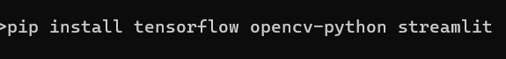

**Gathering Images:**

1. Using Google Chrome select the 3 dot icon or A grey dot on a white background

   AI-generated content may be incorrect. icon at the top right and select Extensions >> Visit Chrome Webstore
2. Type the following into the search bar -> Download All Images
3. Press the “Add to Chrome” button